Pseudocode:

Pseudocode is known as Structured English.
Pseudocode is a way of writing a program that generalizes it for conversion into a programming language.
Pseudocode represents the steps of the program in natural language and mathematical notation.
Pseudocode describes the logic of the program or algorithm.

Example:

ALGORITHM askName()

BEGIN
PRINT "What is your name?"
INPUT name
PRINT "Hello, " + name
END

Common keywords below are in UPPERCASE.

Python | Pseudocode
== | =
= | <-
print | OUTPUT or PRINT or DISPLAY
input | INPUT or GET
if | IF ….THEN
elif | ELSEIF ….THEN
else | ELSE
“end of if” | ENDIF
for | FOR
“end of for” | ENDFOR
while | WHILE
“end of while” | ENDWHILE
or | OR
and | AND
not | NOT
True | TRUE
False | FALSE
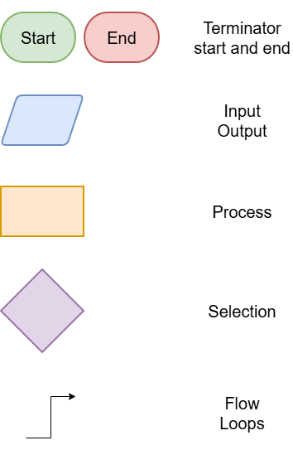

Flowchart:

A flowchart is a visual diagram that illustrates the logical sequence of steps in an algorithm.
Different shapes and colours are used to represent specific instructions or decisions.

The fundamental components of a flowchart include:

- Start and End points marking the start and end of the algorithm
- Data input
- Output of results
- Processes such as assignments, calculations
- Selection diamonds for a decision that determine the next path in the workflow
- Lines with Arrows indicating the order in which steps are carried out, especially for loops.

Pseudocode: Input – Ask Name

ALGORITHM askName()

BEGIN
PRINT "What is your name?"
INPUT name
PRINT "Hello, " + name
END

- What shape is used to start and end the flowchart?
- What shape is used for input?
- What keyword (in caps) indicates output?
- What shape is used for output?
- In the pseudocode above, what is used to indicate that the PRINT and INPUT statements are part of the sequence of steps between the BEGIN and END?

Flowchart:

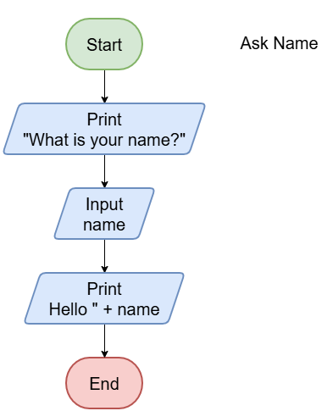

Pseudocode: Input – Favourite Colour

ALGORITHM favouriteColour()

START
PRINT "What is your favourite colour?"
INPUT colour
PRINT colour + " is lovely!"
END

Indenting means adding tabs at the beginning of lines to visually group related statements.
Indent after control statements like IF, ELSE, ELSEIF, WHILE, FOR.
Unindent after closing blocks like ENDIF, ENDWHILE, ENDFOR.

- In the incorrect pseudocode above, what keypress is missing before each PRINT and INPUT statements?
Mark it in before each of the 3 lines.
- On the flowchart, draw the correct shape for input statement (INPUT).
- On the flowchart, draw the correct shape for the output statements (PRINT).

Flowchart:

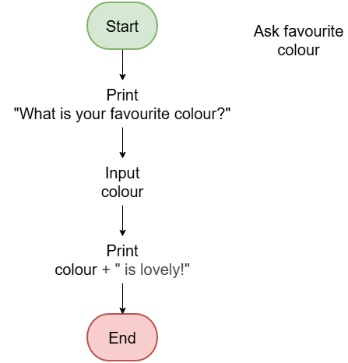

Pseudocode: Process – Area of a rectangle

ALGORITHM rectangleArea()

BEGIN
INPUT l, w
A ← l * w
PRINT A
END

- What shape is used to calculate the area using length and width?
- In the pseudocode above, what symbol is used for multiplication?
When calculating the area, the value is put in the variable, A. This is known as assignment. A value is assigned to the variable, A.
A ← l * w can be read out as "A gets l times w"

- In the pseudocode above, what symbol is used for assignment?
What common maths symbol does this replace from the flowchart?

Flowchart:

The new shape in the flowchart (Compute A = l x w), is for a process, such as calculating a variable using a formula.
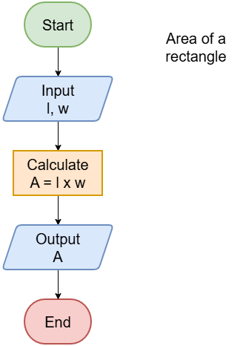

Pseudocode: Process – Area of a square

ALGORITHM squareArea()

BEGIN
INPUT l
A ← l * l
PRINT A
END

- On the flowchart, draw the correct shape for the process.

Flowchart:

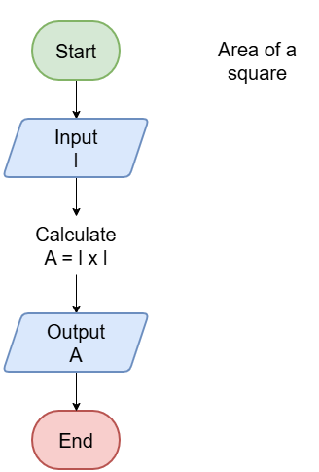

Pseudocode: Process – Area of a parallelogram

ALGORITHM parallelogramArea()

BEGIN
INPUT b, h
A ← b * h
PRINT A
END

- On the flowchart, fill in the shapes with text to represent the pseudocode above.

Flowchart:

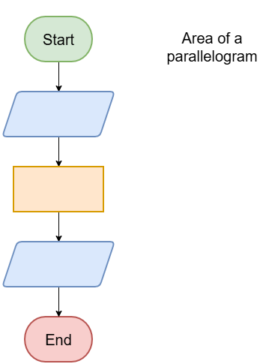

Pseudocode: Selection1 – positive number

ALGORITHM positiveOrNot()

BEGIN
INPUT number
IF number > 0 THEN
PRINT number + " is positive."
ELSE
PRINT number + " is not positive."
ENDIF
END

- What shape is used for a decision?
- In the pseudocode above, what keywords start and end the line that checks the number?
- In the pseudocode above, what keyword starts the code for the NO branch of the flowchart?

- In the pseudocode above, what keyword ends the code for the IF block?

Flowchart:

The new shape in the flowchart (number > 0?), is for a decision, which tests a condition and answers True (Yes) or False (No). These decisions are written on each branch line.

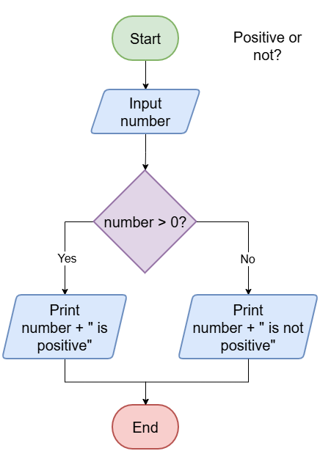

Pseudocode: Selection1 – jumper or not

ALGORITHM jumperOrNot()

BEGIN
INPUT temperature
IF temperature < 20 THEN
PRINT "Wear jumper."
ELSE
PRINT "No jumper."
ENDIF
END

Selection provide alternatives or branches in the code.
In the code above, the temperature determines whether a jumper will be worn or not.

- Use the pseudocode to add the missing text to the flowchart.

Flowchart:
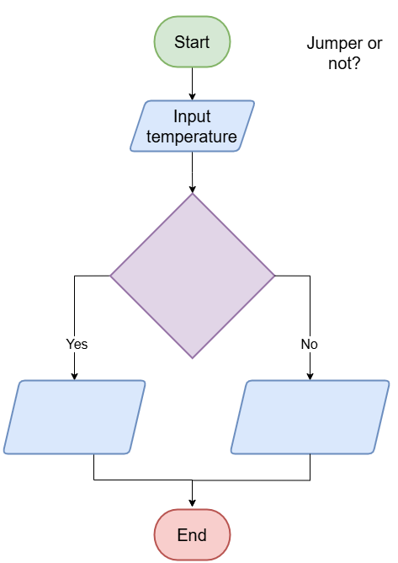

Pseudocode: Selection1 – study or not

ALGORITHM studyOrNot ()

BEGIN
INPUT examSoon
IF examSoon = 'yes' THEN
PRINT "Time to study."
ELSE
PRINT "Take a break."
ENDIF
END

These operators are used in conditions to compare values.
Operator | Meaning | Example Sentence
= | Equal to | If score = 100, print "Perfect!"
!= | Not equal to | If color != "red", change to "blue".
> | Greater than | If speed > 60, show "Slow down!"
< | Less than | If age < 18, deny access.
>= | Greater than or equal to | If temperature >= 30, turn on fan.
<= | Less than or equal to | If hours <= 8, allow break.

- In the pseudocode above what is the comparison operator used to test equality?
- Use the pseudocode to add the missing text to the flowchart.

Flowchart:

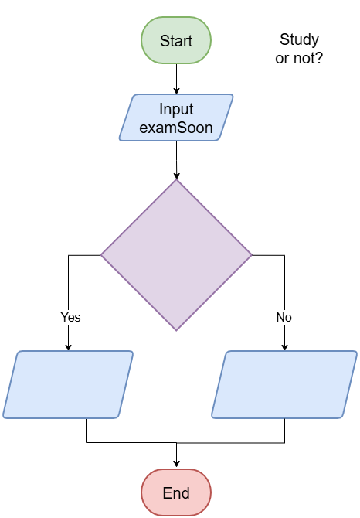

Pseudocode: Selection2 - what to wear

ALGORITHM whatToWear()

BEGIN
INPUT temperature
IF temperature < 10 THEN
PRINT "Wear a coat."
ELSEIF temperature < 20 THEN
PRINT "Wear a jumper."
ELSE
PRINT "Wear a shirt."
ENDIF
END

ELSEIF (or ELSE IF) is used in pseudocode to handle multiple conditions in a decision-making structure. It allows you to check additional conditions if the first IF condition is false — without ending the decision block.

- In the pseudocode above, there are two lines that end with THEN. What keywords do those lines start with?
- What do you wear if the first condition is False and the second is True?
- What do you wear if all conditions are False?
w

Flowchart:
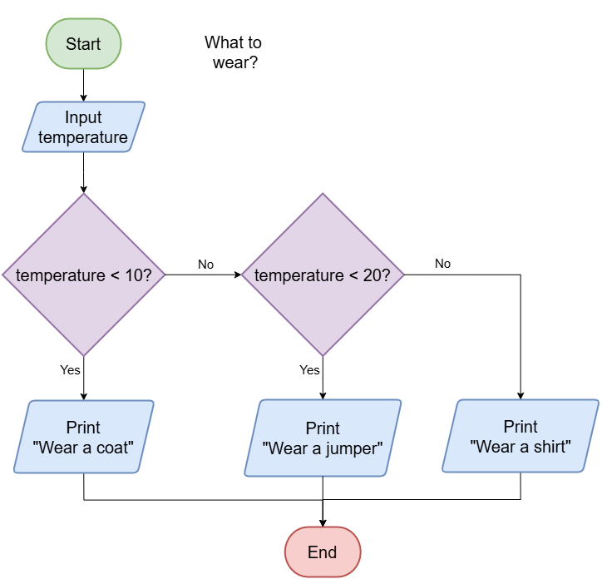

Pseudocode: Selection2 – quadrilaterals by sides
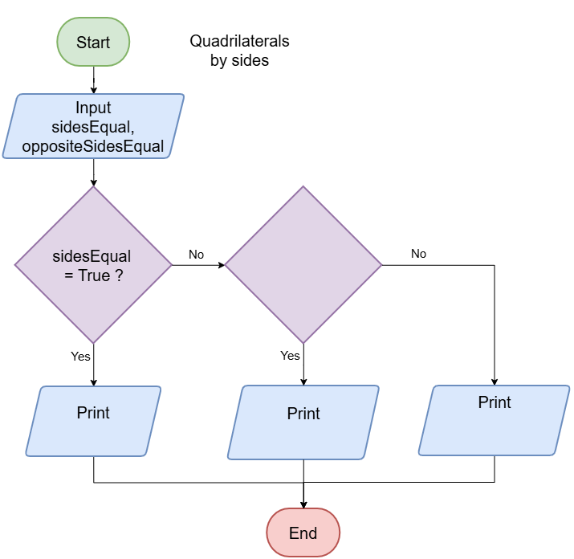

ALGORITHM classifyQuadrilateralBySides()

BEGIN
INPUT sidesEqual, oppositeSidesEqual
IF sidesEqual = TRUE THEN
PRINT "Rhombus"
ELSEIF oppositeSidesEqual = TRUE THEN
PRINT "Parallelogram"
ELSE
PRINT "Other quadrilateral"
ENDIF
END

- Use the pseudocode to add the missing text to the flowchart.

Flowchart:

Pseudocode: Selection (nested)– quadrilaterals by angles

ALGORITHM classifyQuadrilateralBySidesAndAngles()

BEGIN
INPUT oppositeSidesEqual
INPUT anglesRight

IF oppositeSidesEqual = TRUE THEN
IF anglesRight = TRUE THEN
PRINT "Rectangle"
ELSE
PRINT "Parallelogram"
ENDIF
ELSE
PRINT "Other quadrilateral"
ENDIF
END

- Use the pseudocode to add the missing text to the flowchart.

Flowchart:
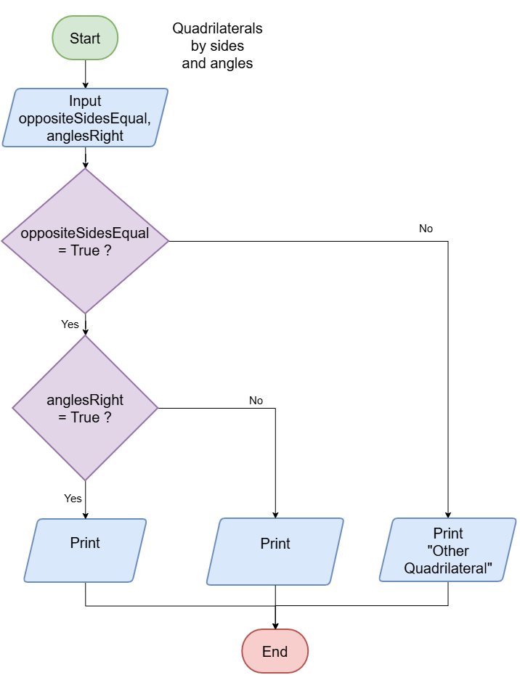

Pseudocode: Selection (and/or)– triangles by sides

Logical operators are used to combine conditions in decision-making.
Operator | Name | Description
AND | Logical AND | True only if both conditions are true
OR | Logical OR | True if at least one condition is true
NOT | Logical NOT | Reverses the truth value (true → false)

ALGORITHM triangleType()

BEGIN
INPUT sideA, sideB, sideC
IF sideA = sideB AND sideB = sideC THEN
PRINT "Equilateral triangle."
ELSEIF sideA = sideB OR sideB = sideC OR sideA = sideC THEN
PRINT "Isosceles triangle."
ELSE
PRINT "Scalene triangle."
ENDIF
END

- In the pseudocode, in the IF statement above, which logical operator is used to see if all 3 sides are of equal length?
- In the pseudocode, in the ELSEIF statement above, what is the most number of sides that can be equal?
Flowchart:

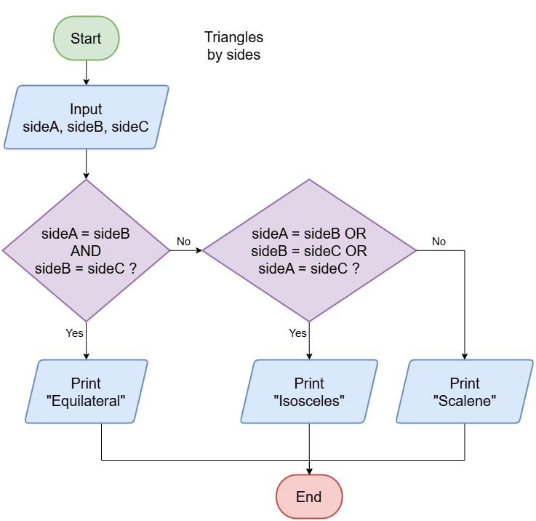

Pseudocode: Selection (and/or)– triangles by angles

ALGORITHM triangleAngleType()

BEGIN
INPUT angleA, angleB, angleC

IF angleA + angleB + angleC ≠ 180 THEN
PRINT "Not a valid triangle."
ELSEIF angleA < 90 AND angleB < 90 AND angleC < 90 THEN
PRINT "Acute triangle."
ELSEIF angleA = 90 OR angleB = 90 OR angleC = 90 THEN
PRINT "Right triangle."
ELSE
PRINT "Obtuse triangle."
ENDIF
END

- In the pseudocode, why is there no need for a test for an angle greater than 90: IF angleA > 90 OR angleB > 90 OR angleC > 90 THEN?

- Use the pseudocode to add the missing text to the flowchart.
Flowchart:

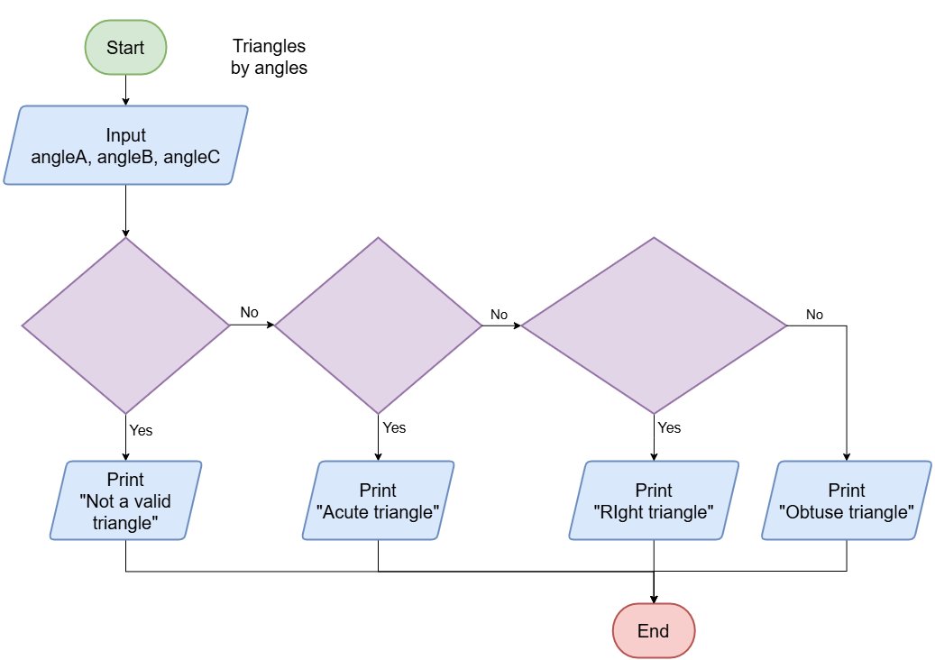

Pseudocode: : Selection (and)– angle types
ALGORITHM angleType()

BEGIN
INPUT angle
-- Outer validation
IF angle > 0 AND angle <= 360 THEN
-- First split: 0–180 vs 180–360
IF angle <= 180 THEN
-- Subsplit: 0–90 vs 90–180
IF angle <= 90 THEN
IF angle > 0 AND angle < 90 THEN
PRINT "Acute angle."
ELSE
PRINT "Right angle."
ENDIF
ELSE
IF angle > 90 AND angle < 180 THEN
PRINT "Obtuse angle."
ELSE
PRINT "Straight angle."
ENDIF
ENDIF
ELSE
-- Subsplit: 180–360
IF angle < 360 THEN
PRINT "Reflex angle."
ELSE
PRINT "Revolution angle."
ENDIF
ENDIF
ELSE
PRINT "Invalid angle."
ENDIF
END

Flowchart:
- Use the pseudocode to add the missing text to the flowchart.

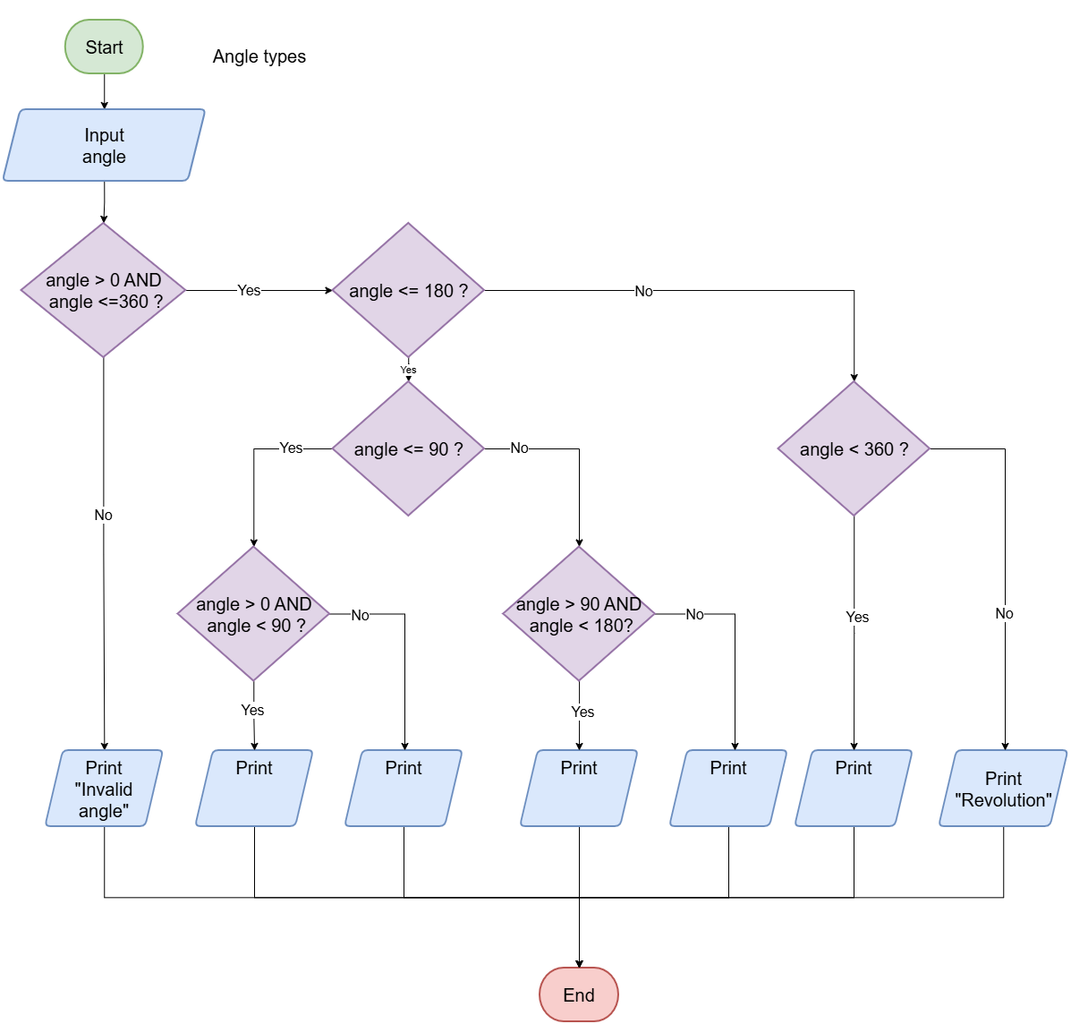

ALGORITHM triangleAngleType()

BEGIN
INPUT angleA, angleB, angleC

// Step 1: Check validity
IF angleA + angleB + angleC ≠ 180 THEN
PRINT Not a valid triangle.
ELSE
// Step 2: Loop through each angle
SET hasRight = false
SET hasObtuse = false

FOR each angle IN [angleA, angleB, angleC] DO
IF angle = 90 THEN
hasRight = true
ELSEIF angle > 90 THEN
hasObtuse = true
ENDIF
ENDFOR

// Step 3: Decide triangle type
IF hasRight = true THEN
PRINT Right triangle.
ELSEIF hasObtuse = true THEN
PRINT Obtuse triangle.
ELSE
PRINT Acute triangle.
ENDIF
ENDIF
END

